**Attachment II**

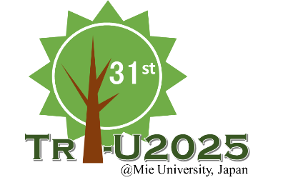

**Application Form**

***The 31st Tri-U International Joint Seminar & Symposium 2025***

***Mie University, Japan***

|  |  |
| --- | --- |
| Name | (Given) (Family) |
| Gender | 🞎 Female 🞎 Male |
| Academic Affiliation |  |
| Position/ Grade |  |
| Address |  |
| Phone: |
| E-mail: |
| Paper title* |  |
| Themes* | (Please circle one or more themes for your paper)  🞎 Population 🞎 Food 🞎 Energy 🞎 Environment  🞎 Disaster Management |
| Smoking | 🞎 I smoke. 🞎 I do not smoke. |
| Dietary restrictions | 🞎 Vegetarian 🞎 Muslim 🞎 Other(my allergy ⇒　　) |

*Only those who will present a paper should fill in these blanks.

**Note: Please send this form by PDF and WORD files to tri-u.info@cie.mie-u.ac.jp**  
**Deadline:**  **May 14, 2025**