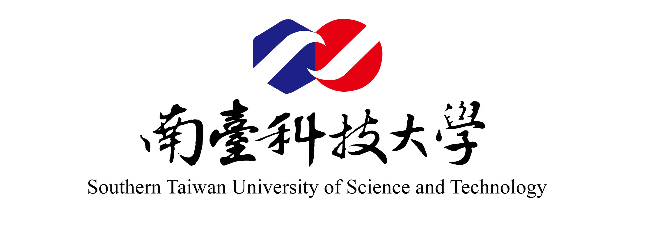

2017華語暨臺灣文化體驗營申請表
Attach recent photo here 3.5cm*4.5cm

Application Form for Chinese Language and
Taiwanese Culture Experience Camp

一、個人資料Personal information

1. 名/Given name: 姓/Family name:
中文姓名/ Chinese name: 國籍/Nationality:
2. 護照號碼/Passport No.:
有效期限/Expire Date: 年/Year 月/Month 日/Day
3. 性別/Sex: □男/M □女/F
4. 出生日期/Date of birth: 年/Year 月/Month 日/Day
5. 通訊地址/Mailing address:
E-mail: FAX:
6. 聯絡電話/Telephone No.: (國碼/Country Code )
緊急連絡/Emergency Contact:
名字Name: 關係Relationship:
電話Telephone No.: (Home) (國碼/Country Code )
(Office) (國碼/Country Code )
地址Address：:
二、教育背景/Educational background
學校 | 修業起迄年月 | 主修 | 文憑
Educational Institute | Duration (from/to) | Field of Study | Diploma

三、中文語言能力/Chinese Language Proficiency:
(請用優,良,可,差來評斷,Please indicate your Chinese proficiency: Excellent, Good, Fair, Poor)

讀/Reading | 寫/ Writing | 聽/ Listening | 說/ Speaking

中文/ Chinese Language background:
是否學過中文? / Have you ever studied Chinese before? □ 否/No □ 是/Yes
如果有If yes, 何時/When 學了多久/ For how long
在哪學習/Where 使用什麼教材/ What textbook you used
說與聽Speaking & Listening:
□我可以用中文自我介紹/I can introduce myself in Chinese
□我有基本中文對話能力/I can carry a basic conversation in Chinese
□我可以用中文與人聊天或談論時事/I can talk about gossip & current news in Chinese
藉由在本活動學習中文，你想要獲得什麼?
What are the goals that you hope to achieve through your participation in the summer camp?

四、其他/Other:
(請用優,良,可,差來評斷,Please indicate your proficiency: Excellent, Good, Fair, Poor)
1. 健康情況/Health condition:□ Good □ Average □ Poor (condition:_____________________)
2. 飲食/Dietry
□ 素食者/ Vegetarian □ 非素食者/ non-vegetarian □ 其他/ others
3. 如何得知此活動訊息？/ How do you get the information of this summer camp?
□朋友/friends □學校/university □校友/ alumni □其他/ others
4. 是否參加周末接待家庭活動?/Are you interested in joining our weekend host family program?
□是Yes (Please fill out the Weekend Hostfamily Activity Application Form ) □否 No
五、聲明與簽名/Declaration and Signature:
1. I certify that the information on my application is correct and agree to keep it updated as necessary.
2. I understand that becoming a participant in 2017 Chinese Language and Taiwanese Culture Experience Camp at Southern Taiwan University of Science and Technology (STUST), I am subject to full participation in the program. In addition, I agree to fully abide by the regulations of the university and the law of the host country.
3. I understand that STUST cannot be held responsibility for any injuries, loss of damage to my person and property. I understand that there are risks associated with activities abroad in addition to those which relate to culture differences or other local conditions.
4. I understand that my home university may be contacted regarding issues that relate to my health and safety which may arise during or behavior regarding my participation in this camp.
5. I understand that STUST reserves the right to alter or cancel any course at any time due to unforeseen circumstances.
6. I have read the 2017 Chinese Language and Taiwanese Culture Experience Camp Handbook and agree to comply the policies and conditions therein.

申請人簽名/ Signature of applicant: 日期/Date:

家長或監護人簽名/Parent/ Guardian Signature: (Required if student is under 20) 日期/Date:

