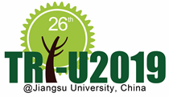
Application Form
The 26th Tri-U International Joint Seminar & Symposium 2019
Jiangsu University, China

Name | ^{(Given)} ^{(Family)}
Gender | 1. Female 2. Male
Affiliation
Position
Address
 | Mie University | Phone:
 | E-mail:
Paper title*
Themes* | (Please circle one or more themes for your paper)  < Population > < Food > < Energy > < Environment > < The Belt and Road >
Abstract* | (up to 200 words)
*Only those who will present a paper should fill in these blanks.

*Additional Information.
Smoking | 1. I smoke. 2. I do not smoke.
Dietary restrictions | 1. Vegetarian 2. Muslim 3. Other(my allergy ⇒ )
学内提出用  【必須】 | 指導教官名： 印
※論文の発表内容について，指導教官に確認してください。
※指導教官に論文指導が受けられることを確認の上，署名・捺印をいただくこと。

